**ASSIGNMENT 03**

**COMSATS University Islamabad**

Sahiwal Campus



***Usama Sarwar***

FA17-BS(CS)-090-B

***Mr. Khalid Mehmood***

Information Security

December 12, 2020

**Question No # 01**

**Codes of Different Ciphers**

**Additive Cipher:**

The simplest monoalphabetic cipher is the additive cipher. This cipher is sometimes called a shift cipher and sometimes a Caesar cipher, but the term additive cipher better reveals its mathematical nature.

**Code:**

package additive.cipher;

import java.util.*;

/**

*

*/

public class AdditiveCipher {

/**

* @param args the command line arguments

*/

public static void main(String[] args) {

// TODO code application logic here

Scanner sc = new Scanner(System.in);

System.out.println(" Input the plaintext message here: ");

String plaintext = sc.nextLine();

System.out.println(" Enter the value by which each character in the plaintext message gets shifted :

");

int shift = sc.nextInt();

String ciphertext = "";

char alphabet;

for(int i=0; i < plaintext.length();i++)

{

// Shift one character at a time

alphabet = plaintext.charAt(i);

// if alphabet lies between a and z

if(alphabet >= 'a' && alphabet <= 'z')

{

// shift alphabet

alphabet = (char) (alphabet + shift);

// if shift alphabet greater than 'z'

if(alphabet > 'z') {

// reshift to starting position

alphabet = (char) (alphabet+'a'-'z'-1);

}

ciphertext = ciphertext + alphabet;

}

// if alphabet lies between 'A'and 'Z'

else if(alphabet >= 'A' && alphabet <= 'Z') {

alphabet = (char) (alphabet + shift);

if(alphabet > 'Z') {

//reshift to starting position

alphabet = (char) (alphabet+'A'-'Z'-1);

}

ciphertext = ciphertext + alphabet;

}

else {

ciphertext = ciphertext + alphabet;

}

}

System.out.println(" ciphertext : " + ciphertext);

System.out.println("The decrypted cipher is : "+ plaintext);

}

}

**Output**

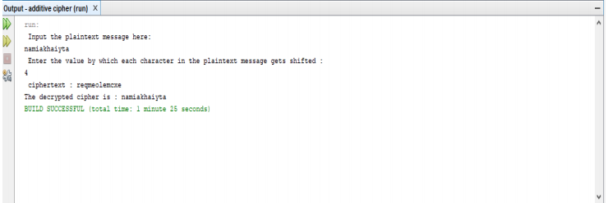

**Multiple Cipher:**

The multiplicative cipher is similar to additive cipher except the fact that the key bit is multiplied to the plain-text symbol during encryption. Likewise, the cipher-text is multiplied by the multiplicative inverse of key for decryption to obtain back the plain-text. The key space of multiplicative cipher is 12.

**Code:**

package multiplicativecipher;

import java.util.*;

/**

*

*/

public class MultiplicativeCipher {

/**

* @param args the command line arguments

*/

public static void main(String[] args) {

// TODO code application logic here Scanner sc=new Scanner(System.in);

int shift,i,n; String str; String str1=""; String str2="";

System.out.println("Implementation of Multiplicative Cipher"); System.out.println("Enter the plaintext");

str=sc.nextLine(); str=str.toLowerCase(); n=str.length();

char ch1[]=str.toCharArray(); char ch3;

char ch4;

System.out.println("Enter the value by which each letter of the string is to be shifted"); shift=sc.nextInt();

System.out.println(); System.out.println("Encrypted text is");

for(i=0;i<n;i++)

{

if(Character.isLetter(ch1[i]))

{

ch3=(char)(((int)ch1[i]*shift-

{

str1=str1+ch1[i];

}

}

System.out.println(str1);

inverse int q=0,flag=0;

for(i=0;i<26;i++)

{

if(((i*26)+1)%shift==0)

{

q=((i*26)+1)/shift; break;

}

}

System.out.println(); System.out.println("Decrypted text is"); char ch2[]=str1.toCharArray(); for(i=0;i<str1.length();i++)

{

if(Character.isLetter(ch2[i]))

{

ch4=(char)(((int)ch2[i]*q-97)%26+97); str2=str2+ch4;

}

else if(ch2[i]==' ')

{

str2=str2+ch2[i];

}

}

System.out.println(str2);

}

}

# **Output:**

# 

**Affine Cipher:**

The affine cipher is a type of monoalphabetic substitution cipher, where each letter in an alphabet is mapped to its numeric equivalent, encrypted using a simple mathematical function, and converted back to a letter.

**Code:**

package affinecipher; import java.util.*;

/**

*

*/

public class Affinecipher {

// Key values of a and b static int a = 17;

static int b = 20;

static String encryptMessage(char[] msg)

{

/// Cipher Text initially empty String cipher = "";

for (int i = 0; i < msg.length; i++)

{

// Avoid space to be encrypted

/* applying encryption formula ( a x + b ) mod m

{here x is msg[i] and m is 26} and added 'A' to bring it in range of ascii alphabet[ 65-90 | A-Z ] */ if (msg[i] != ' ')

{

cipher = cipher

+ (char) ((((a * (msg[i] - 'A')) + b) % 26) + 'A');

} else // else simply append space character

{

cipher += msg[i];

}

}

return cipher;

}

static String decryptCipher(String cipher)

{

String msg = ""; int a_inv = 0; int flag = 0;

//Find a^-1 (the multiplicative inverse of a

//in the group of integers modulo m.) for (int i = 0; i < 26; i++)

{

flag = (a * i) % 26

// Check if (a*i)%26 == 1,

// then i will be the multiplicative inverse of a if (flag == 1)

{

a_inv = i;

}

}

for (int i = 0; i < cipher.length(); i++)

{

/*Applying decryption formula a^-1 ( x - b ) mod m

{here x is cipher[i] and m is 26} and added 'A'

to bring it in range of ASCII alphabet[ 65-90 | A-Z ] */ if (cipher.charAt(i) != ' ')

{

msg = msg + (char) (((a_inv * ((cipher.charAt(i) + 'A' - b)) % 26)) + 'A');

}

else //else simply append space character

{

msg += cipher.charAt(i);

}

}

return msg;

}

/**

* @param args the command line arguments

*/

public static void main(String[] args) {

// TODO code application logic here

Scanner S= new Scanner(System.in);

System.out.println("Implementation of Affine-Cipher is : ");

System.out.println("Enter the text here : "); String msg = S.nextLine(); System.out.println("Actual String :" + msg);

// Calling encryption function

String cipherText = encryptMessage(msg.toCharArray()); System.out.println("Encrypted Message is : " + cipherText);

// Calling Decryption function System.out.println("Decrypted String :" + msg);

}

**Output**

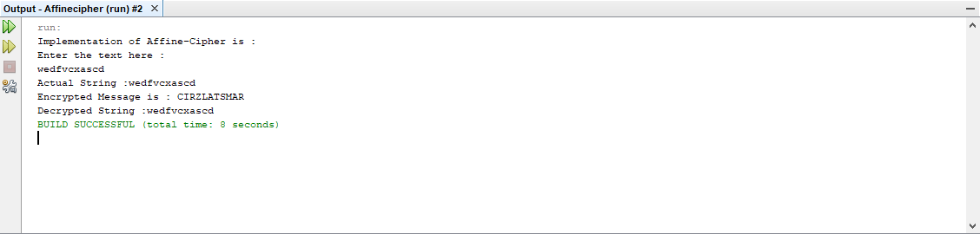

**Playfair Cipher:**

The Playfair cipher or Playfair square or Wheatstone-Playfair cipher is a manual symmetric encryption technique and was the first literal diagram substitution cipher.

**Code:**

package plafaircipher; import java.util.*; import java.util.Scanner;

/**

*

* @author LAPTOP POINT

*/

public class Plafaircipher {

private String KeyWord = new String(); private String Key = new String(); private char matrix_arr[][] = new char[5][5];

public void setKey(String k)

{

String K_adjust = new String();

boolean flag = false;

K_adjust = K_adjust + k.charAt(0); for (int i = 1; i < k.length(); i++)

{

for (int j = 0; j < K_adjust.length(); j++)

{

if (k.charAt(i) == K_adjust.charAt(j))

{

flag = true;

}

}

if (flag == false)

K_adjust = K_adjust + k.charAt(i); flag = false;

}

KeyWord = K_adjust;

}

public void KeyGen()

{

boolean flag = true; char current;

Key = KeyWord;

for (int i = 0; i < 26; i++)

{

current = (char) (i + 97); if (current == 'j')

continue;

for (int j = 0; j < KeyWord.length(); j++)

if (current == KeyWord.charAt(j))

{

flag = false; break;

}

}

if (flag)

Key = Key + current; flag = true;

}

System.out.println(Key); matrix();

}

private void matrix()

{

int counter = 0;

for (int i = 0; i < 5; i++)

{

for (int j = 0; j < 5; j++)

{

matrix_arr[i][j] = Key.charAt(counter); System.out.print(matrix_arr[i][j] + " "); counter++;

}

System.out.println();

}

}

private String format(String old_text)

{

int i = 0; int len = 0;

String text = new String(); len = old_text.length();

for (int tmp = 0; tmp < len; tmp++)

{

if (old_text.charAt(tmp) == 'j')

{

text = text + 'i';

}

else

text = text + old_text.charAt(tmp);

}

len = text.length();

for (i = 0; i < len; i = i + 2)

{

if (text.charAt(i + 1) == text.charAt(i))

{

text = text.substring(0, i + 1) + 'x' + text.substring(i + 1);

}

}

return text;

}

private String[] Divid2Pairs(String new_string)

{

String Original = format(new_string); int size = Original.length();

if (size % 2 != 0)

{

size++;

Original = Original + 'x';

}

String x[] = new String[size / 2]; int counter = 0;

for (int i = 0; i < size / 2; i++)

{

x[i] = Original.substring(counter, counter + 2); counter = counter + 2;

}

return x;

}

public int[] GetDiminsions(char letter)

{

int[] key = new int[2]; if (letter == 'j')

letter = 'i';

for (int i = 0; i < 5; i++)

{

for (int j = 0; j < 5; j++)

{

if (matrix_arr[i][j] == letter)

{

key[0] = i;

key[1] j; break;

}

return key;

}

public String encryptMessage(String Source)

{

String src_arr[] = Divid2Pairs(Source); String Code = new String();

char one; char two;

int part1[] = new int[2]; int part2[] = new int[2];

for (int i = 0; i < src_arr.length; i++)

{

one = src_arr[i].charAt(0); two = src_arr[i].charAt(1); part1 = GetDiminsions(one); part2 = GetDiminsions(two); if (part1[0] == part2[0])

{

if (part1[1] < 4) part1[1]++;

else

part1[1] = 0; if (part2[1] < 4)

part2[1]++; else

part2[1] = 0;

}

else if (part1[1] == part2[1])

{

if (part1[0] < 4) part1[0]++;

GetDiminsions(two); if (part1[0] == part2[0])

{

if (part1[1] < 4) part1[1]++;

else

part1[1] = 0; if (part2[1] < 4)

part2[1]++; else

part2[1] = 0;

}

else if (part1[1] == part2[1])

{

if (part1[0] < 4) part1[0]++;

else

part1[0] = 0; if (part2[0] < 4)

part2[0]++; else

part2[0] = 0;

}

else

{

int temp = part1[1]; part1[1] = part2[1]; part2[1] = temp;

}

Code = Code + matrix_arr[part1[0]][part1[1]]

+ matrix_arr[part2[0]][part2[1]];

}

return Code;

}

/**

* @param args the command line arguments

*/

public static void main(String[] args) {

// TODO code application logic here Plafaircipher x = new Plafaircipher(); Scanner sc = new Scanner(System.in);

System.out.println("Implementation of Playfair Cipher:");

System.out.println("Enter a keyword:"); String keyword = sc.next(); x.setKey(keyword);

x.KeyGen(); System.out

.println("Enter word to encrypt: (Make sure length of message is even)"); String key_input = sc.next();

if (key_input.length() % 2 == 0)

{

System.out.println("Encryption: " + x.encryptMessage(key_input));

}

else

{

System.out.println("Message length should be even");

}

sc.close();

}

**Output**

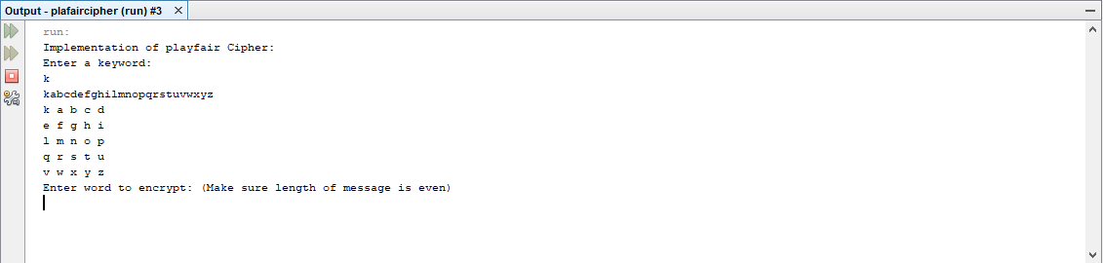

**Autokey Cipher:**

An autokey cipher is a cipher that incorporates the message into the key. The key is generated from the message in some automated fashion, sometimes by selecting certain letters from the text or, more commonly, by adding a short primer key to the front of the message.

**Code:**

package autokey; import java.lang.*; import java.util.*;

/**

*

public class Autokey {

private static final String alphabet = "ABCDEFGHIJKLMNOPQRSTUVWXYZ";

/**

* @param args the command line arguments

*/

public static void main(String[] args) {

// TODO code application logic here

String msg = "INFORMATION SECURITY";

String key = "K";

// This if statement is all about java regular expression

// [] for range

// // Extra \ is used to escape one \

// \\d acts as delimiter

// ? once or not at all

// . Any character (may or may not match line terminators) if (key.matches("[-+]?\\d*\\.?\\d+"))

key = "" + alphabet.charAt(Integer.parseInt(key)); String enc = autoEncryption(msg, key);

System.out.println("Implemenation of Autokey-Cipher : "); System.out.println("Plaintext is : " + msg); System.out.println("Encrypted is : " + enc); System.out.println("Decrypted is : " + autoDecryption(enc, key));

}

public static String autoEncryption(String msg, String key)

{

int len = msg.length();

// generating the keystream

String newKey = key.concat(msg);

newKey = newKey.substring(0, newKey.length() - key.length()); String encryptMsg = "";

// applying encryption algorithm for (int x = 0; x <

len; x++) {

int first = alphabet.indexOf(msg.charAt(x));

int second = alphabet.indexOf(newKey.charAt(x)); int total = (first + second) % 26;

encryptMsg += alphabet.charAt(total);

}

return encryptMsg;

}

public static String autoDecryption(String msg, String key)

{

String currentKey = key;

String decryptMsg = "";

// applying decryption algorithm

for (int x = 0; x < msg.length(); x++) {

int get1 = alphabet.indexOf(msg.charAt(x));

int get2 = alphabet.indexOf(currentKey.charAt(x)); int total = (get1 - get2) % 26;

total = (total < 0) ? total + 26 : total; decryptMsg += alphabet.charAt(total); currentKey += alphabet.charAt(total);

}

return decryptMsg;

}

}

**Output**

